AFTERNOON PROGRAMS
Tuesdays and Thursdays 3 - 5 pm

Karratha Family Centre offers two afternoon sessions during school Terms from 3 -5pm for children aged 5-10 years old. Parents do not need to stay but are welcome to stay and join in the activities and fun with their children.

Construction Tuesday consists of a variety of hands-on activities for children to explore and create using their fine motor skills. It allows children to work individually or together in teams and interact socially with other children. The program is conducted both indoors and outdoors. Nature play is an integral part of our afternoon programs.


Arts and Crafts Thursday consists of a variety of art/craft activities led by the children attending each week. Children will have the opportunity to complete a guided activity with the facilitator or to engage in other activities independently or in small groups. The program is conducted both indoors and outdoors. Nature play is an integral part of our afternoon programs.

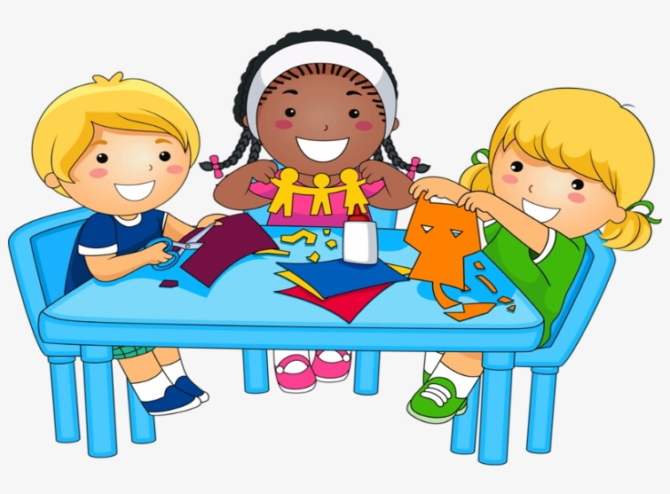

AFTERNOON PROGRAMS
Tuesdays and Thursdays 3 - 5 pm

Days your child/ren will be attending: Term 1 / 2 / 3/ 4 Tuesdays and/or Thursdays

Cost: $25 per child for first child; $20 for second child in family; $15 for third child in family; additional children free. Note: Payment is due before commencement of the Term program. Payment plan can be arranged if necessary.

CHILD 1
Name:________________________________ Date of Birth:_________________

Address:___________________________________________________________Male/Female:________

CHILD 2
Name:________________________________ Date of Birth:_________________

Address:___________________________________________________________Male/Female:________

CHILD 3

Name:________________________________ Date of Birth:_________________

Address:___________________________________________________________Male/Female:________

PARENT/GUARDIAN

Full Name:_________________________________________________________

Home Address:______________________________________________________

Mobile Phone: _____________________Email:_____________________________

EMERGENCY CONTACT

Full Name:_________________________________________________________

Relationship to Child:____________________ Mobile phone: _______________

Home Address:_________________________

I DO / DO NOT give permission for the above person to collect my child from Karratha Family Centre at the end of the Afternoon Program each week.

MEDICAL INFORMATION:

Does your child have any allergies? Yes / No
If so, please describe:___________________________________________________________

Does your child suffer from asthma or any other health concerns? Yes / No
If so, please describe__________________________________________________________
Does your child have any special needs which you would like us to be aware of? (eg cultural, religious, disabilities, dietary etc) Yes / No

If so please provide more information: __________________________________________________________________________________________________________________________________________________________________________

PERMISSIONS

Please tick yes or no to specify your approved/denied permissions;

 |  | YES | NO
Photos of your child | To be used within the Centre
 | To be used outside the Centre
To be posted in private SR Facebook group
(these groups will only consist of parents of children attending the same day for communication purposes only)
To be used on our website and social media
( Facebook / Instagram / promotional emails)
Transport | For your child to be transported in a motor vehicle should the emergency need arise?
Health & safety | To apply sunscreen to your child where needed
 | To apply insect repellent to your child where needed

What to bring: Water bottle; Hat; Snacks (no nuts please). Fruit will be supplied.

I understand that if my child/ren become disruptive or endanger the safety of other children, I will be contacted for immediate collection.

If you have any Family Arrangements, needs, and/or concerns please arrange to speak to us privately.

PARENT / GUARDIAN ACKNOWLEDGEMENT

I confirm that all details provided are true and correct, and I understand that The Karratha Family Centre Inc is not liable for injury or incidents which may occur during the program sessions.

Name :______________________ (Please Print ) Signature :_________________________Date :__/__/__

PAYMENT FOR AFTERNOON PROGRAMS:

Payment to be made in full prior to the commencement of each Term’s program
Payment by electronic transfer to:
Karratha Family Centre Inc BSB 036 187 Acc 533003
REF: AP # (1,2,or3 for number of children being enrolled) and Full Name of Parent

PLEASE NOTE : All information provided in this registration form is confidential.

